# 

# **Product Dissection for Magic Leap**

# **Research Documentation:**

The detailed research documentation for product dissection of Magic Leap is available on the link below:

<https://docs.google.com/document/d/1wCQbRdZKou_iLyQkdVG1YzD2nVQDAaxUaqa5vZKtEF4/edit?usp=sharing>

# **Company Overview:**

Magic Leap, Inc. is an American technology company that specializes in augmented reality (AR) and virtual reality (VR). Founded by Rony Abovitz in 2010, Magic Leap has gained significant recognition for its groundbreaking AR technology. One of its flagship products is the "Magic Leap One," a head-mounted AR display that overlays 3D computer-generated imagery onto the real world. Magic Leap's mission revolves around constructing a light-field chip using silicon photonics to create immersive AR and VR experiences.

# **Product Dissection and Real-World Problems Solved by Magic Leap:**

Magic Leap AR/VR platform represents a transformative force in the world of augmented and virtual reality, offering innovative solutions to real-world challenges across various industries. This platform's core focus on spatial computing and immersive experiences redefines the way users interact with digital content and the physical world. By enabling users to seamlessly blend digital and real-life elements, Magic Leap addresses the need for enhanced interaction and engagement, bridging the gap between the virtual and physical realms.

Magic Leap's groundbreaking spatial computing capabilities provide users with a novel way to perceive and interact with their environment. This core feature tackles the challenge of limited immersion in traditional digital experiences, allowing users to engage with digital content as if it were physically present. This immersion extends across industries, from healthcare to education and beyond, offering practical solutions for training, design, collaboration, and more.

Furthermore, Magic Leap's commitment to a robust developer ecosystem empowers creators to innovate and craft diverse AR experiences. This addresses the challenge of content diversity and accessibility by fostering a collaborative environment where developers can push the boundaries of what's possible in AR/VR. It also ensures that the platform continues to evolve to meet the ever-changing needs of users.

In summary, Magic Leap's AR/VR platform is a visionary solution to real-world challenges. It reimagines human-computer interaction, addresses immersion limitations, and fosters creativity and collaboration across domains. Magic Leap's commitment to a user-centered approach and spatial computing capabilities make it a transformative platform, offering practical solutions to the complexities of our digital age.

## **Magic Leap as a Platform:**

* AR Development Platform: Magic Leap provides developers with a platform for creating augmented reality (AR) experiences. Developers can use Magic Leap's tools, **APIs**, and resources to build **AR applications** and content that can run on Magic Leap devices. In this sense, Magic Leap serves as a **platform for AR** development.
* Spatial Computing Platform: Magic Leap is known for its spatial computing capabilities, which allow digital content to interact with the physical world. This aspect of Magic Leap positions it as a platform for creating **spatially aware AR experiences**.

# **Case Study: Real-World Problems and Magic Leap’s Innovative Solutions**

## **1. Remote Collaboration and Communication:**

* **Problem:** With the increasing need for remote work and collaboration, maintaining meaningful connections with colleagues, clients, and loved ones can be challenging. Traditional video calls lack the depth of in-person interactions.
* **Magic Leap's Solution:** Magic Leap's AR technology offers spatial computing, allowing users to engage in lifelike, interactive virtual meetings. This technology can make remote collaboration more immersive and compelling, with participants feeling like they are in the same physical space.

## **2. Medical Training and Visualization:**

* **Problem:** Medical training often relies on textbooks and 2D images, making it challenging for students to grasp complex 3D anatomical structures and procedures.
* **Magic Leap's Solution:** Magic Leap's AR capabilities enable medical professionals and students to visualize and interact with 3D medical models in a realistic way. This can enhance medical education, surgical planning, and patient understanding.

## **3. Retail and E-Commerce:**

* **Problem:** Online shoppers often struggle to visualize how products will look in their physical space before making a purchase.
* **Magic Leap's Solution:** Magic Leap's AR platform can provide virtual "try before you buy" experiences. Shoppers can place virtual products in their homes or surroundings using the headset, helping them make more informed purchase decisions.

## **4. Training and Simulation:**

* **Problem:** Training for high-risk jobs, such as firefighters or pilots, can be costly and dangerous in real-world scenarios.
* **Magic Leap's Solution:** Magic Leap's AR can be used for immersive training simulations, allowing trainees to practice in safe, controlled environments. This reduces costs and risks associated with real-world training.

## **5. Education and Remote Learning:**

* **Problem:** The COVID-19 pandemic highlighted the challenges of remote learning, including engagement and interaction.
* **Magic Leap's Solution:** Magic Leap's technology can bring immersive educational experiences to remote learners, making lessons more engaging and interactive through 3D models and simulations.

### **Conclusion:**

Magic Leap's augmented reality technology represents a groundbreaking approach to solving real-world problems across various domains. From enhancing remote collaboration and medical education to revolutionizing retail and training simulations, Magic Leap's AR platform offers immersive solutions that bring digital content into the physical world. This transformative technology has the potential to reshape industries and provide innovative solutions to some of today's most pressing challenges.

# **Top Features of Magic Leap:**

1. **User Profiles:** Allow users to create and customize profiles with personal information, preferences, and avatars. Personalized experiences, social interactions, and content recommendations.
2. **Spatial Anchors:** Enable users to place spatial anchors in their physical environment for persistent AR content. Users can organize and revisit content in their physical space, enhancing productivity and personalization.
3. **User Authentication and Permissions:** Implement secure user authentication and permission controls for data privacy and security. Protect user data and ensure controlled access to AR experiences. User authentication ensures secure access to the Magic Leap 2 platform, requiring users to log in with their credentials.
4. **Content Discovery and Recommendation:** Offer personalized content discovery and recommendation algorithms based on user preferences and behavior. Enhance user engagement and satisfaction by suggesting relevant AR content.
5. **Interactive Gestures and Controllers:** Integrate support for intuitive gestures and controllers that enable users to interact with AR objects. Improved user interaction and immersion in AR experiences. Interactive gestures and controllers are fundamental for user immersion.
6. **Collaboration Tools:** Provide collaborative features such as real-time sharing of AR content and communication tools for remote teamwork. Facilitate remote collaboration and communication in AR/VR environments.
7. **Content Creation and Editing Tools:** Include tools for users to create, edit, and share their AR content and experiences. Empower users to express creativity and contribute to the AR ecosystem. Empowering users to be content creators fosters creativity and diversity within the platform.
8. **Accessibility Features:** Implement accessibility features, including voice commands, text-to-speech, and customizable interfaces. Ensure inclusivity and usability for users with disabilities. These features make the platform usable by individuals with different abilities, enhancing the user base and promoting diversity.
9. **Community and Social Integration:** Enable users to connect with others, form communities, and share AR experiences. Fostering social engagement and user-generated content. Social integration fosters a sense of belonging and community within the platform.
10. **User Support and Feedback:** Provide in-app support, feedback channels, and user forums for addressing issues and collecting feedback. Enhance user satisfaction and continually improve the platform based on user input. Feedback channels enable users to contribute to platform improvement, making it more user-friendly and adaptable to their needs.

# **Schema Description:**

Magic Leap is an augmented reality (AR) platform known for its spatial computing capabilities. To design a schema for Magic Leap, you would typically need to define the data structures and relationships required for developing AR applications.

* **User Entity:**
  + Attributes:
    - * UserID (Primary Key)
      * Username
      * Email
      * Password (Hashed and Salted)
      * Avatar URL
      * Location
      * Biography
      * Preferences (Stored as JSON or separate table)
  + Relationships:
    - * One-to-Many with Content (User creates and interacts with content)
      * Many-to-Many with Friends (Users can have multiple friends)
      * One-to-Many with Permissions (User's access to shared content)
      * One-to-Many with Interaction History (Record of user interactions)
* **SpatialAnchor Entity:**
  + Attributes:
    - * AnchorID (Primary Key)
      * UserID (Foreign Key to User)
      * Location (3D coordinates)
      * Description
      * Timestamp
  + Relationships:
    - * One-to-one with AR Content (AR content associated with an anchor)
* **Permissions Entity:**
  + Attributes:
    - * PermissionID (Primary Key)
      * ContentID (Foreign Key to AR Content)
      * UserID (Foreign Key to User)
      * AccessLevel (e.g., Read, Write)
  + Relationships:
    - * Many-to-Many with User (User's permissions for shared content)
* **Ar_Content Entity:**
  + Attributes:
    - * ContentID (Primary Key)
      * Title
      * Description
      * Type (e.g., 3D model, video, game)
      * Tags/Categories (Stored as JSON or separate table)
      * Author/Creator (Foreign Key to User)
      * Creation Date
  + Relationships:
    - * One-to-Many with SpatialAnchor (AR content associated with spatial anchors)
      * Many-to-Many with User (Users can like and interact with content)
      * One-to-Many with Author of Content(AR_content)
* **Interaction Entity:**
  + Attributes:
    - * InteractionID (Primary Key)
      * UserID (Foreign Key to User)
      * ARContentID (Foreign Key to AR Content)
      * Timestamp
      * GestureType (e.g., tap, swipe)
      * InteractionDetails (e.g., gesture coordinates)
  + Relationships:
    - * Many-to-One with User (User's interactions)
      * Many-to-One with AR Content (Content interactions)
* **CollaborationSession Entity:**
  + Attributes:
    - * SessionID (Primary Key)
      * Participants (List of UserIDs)
      * Start Time
      * End Time
  + Relationships:
    - * Many-to-Many with User (Users participating in a session)
* **ContentCreation Entity:**
  + Attributes:
    - * CreationID (Primary Key)
      * UserID (Foreign Key to User)
      * ARContentID (Foreign Key to AR Content)
      * CreationDate
      * Editing Tools (e.g., 3D modeling software used)
  + Relationships:
    - * Many-to-One with User (User's content creations)
* **AccessibilitySettings Entity:**
  + Attributes:
    - * SettingsID (Primary Key)
      * UserID (Foreign Key to User)
      * VoiceCommandsEnabled
      * TextToSpeechEnabled
      * CustomizableInterfaces (Stored as JSON)
  + Relationships:
    - * One-to-One with User (User's accessibility settings)
* **Friendship Entity:**
  + Attributes:
    - * FriendshipID (Primary Key)
      * UserID1 (Foreign Key to User)
      * UserID2 (Foreign Key to User)
      * FriendshipStatus (e.g., pending, accepted)
  + Relationships:
    - * Many-to-Many with User (User's friends)
* **SupportTicket Entity:**
  + Attributes:
    - * TicketID (Primary Key)
      * UserID (Foreign Key to User)
      * Category (e.g., technical issue, feedback)
      * Description
      * Status (e.g., open, closed)
      * Timestamp
  + Relationships:
    - * Many-to-One with User (User's support tickets)

# 

# **ER Diagram:**

Let's construct an ER diagram that vividly portrays the relationships and attributes of the entities within the Instagram schema. This ER diagram will serve as a visual representation, shedding light on the pivotal components of Instagram's data model. By employing this diagram, you'll gain a clearer grasp of the intricate interactions and connections that define the platform's dynamics.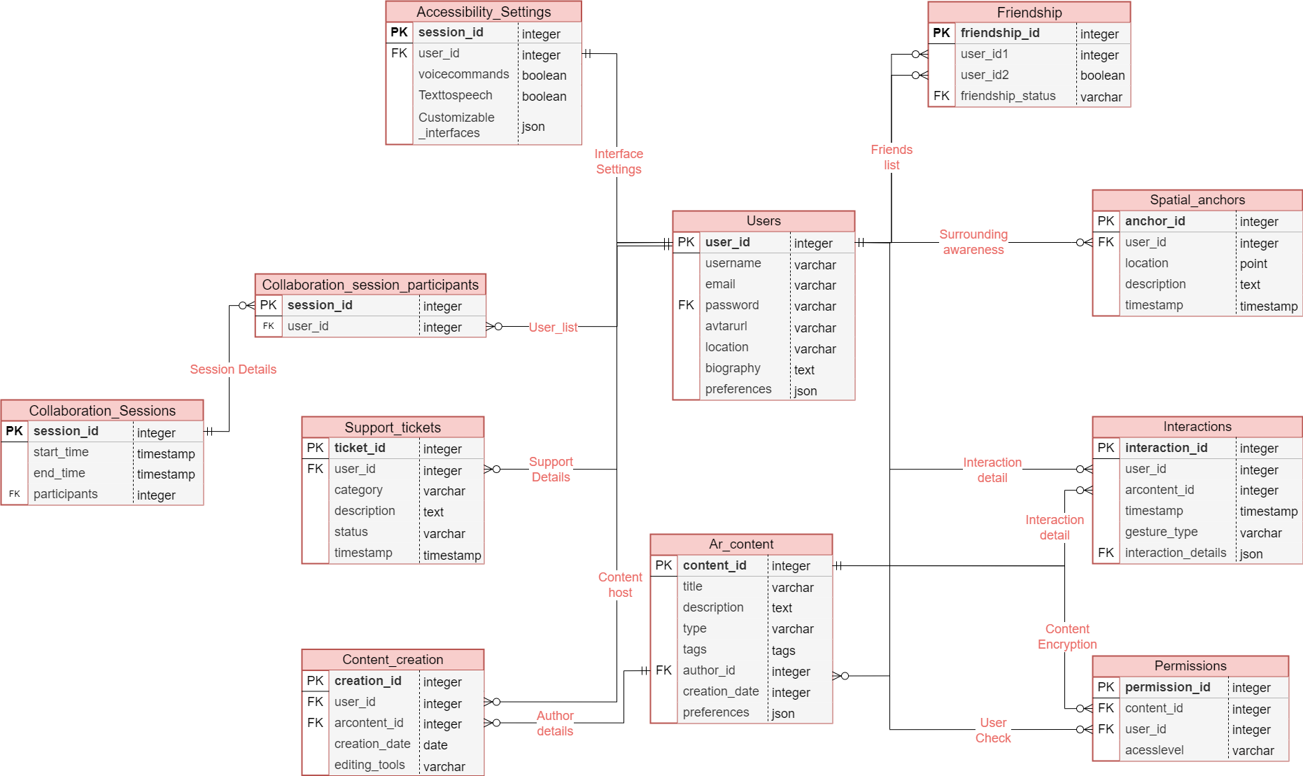

# 

# 

# 

# **Conclusion:**

In this case study, we have delved into the design of the schema and Entity-Relationship diagram for the Magic Leap 2 AR/VR platform. Magic Leap 2 represents a significant leap forward in augmented reality and virtual reality technology, offering immersive experiences that blend digital and physical worlds. The platform's intricate data model encompasses entities such as users, spatial anchors, content, permissions, interactions, and more. This schema serves as the backbone for Magic Leap 2's user-centered features and functionality, providing a foundation for seamless user experiences in the realm of AR and VR.

By comprehending this schema, we gain valuable insights into how Magic Leap 2 efficiently manages the complexities of user interactions, content creation and sharing, collaboration, and accessibility. This understanding underscores the platform's commitment to user-centric design, security, and inclusivity, contributing to its potential for transformation in various domains, from education and healthcare to entertainment and beyond. Magic Leap 2's schema forms the basis for an ecosystem that empowers users to explore, create, collaborate, and innovate, solidifying its position as a pioneering AR/VR platform that shapes the future of human-computer interaction.